**Anti-Lock Braking System**

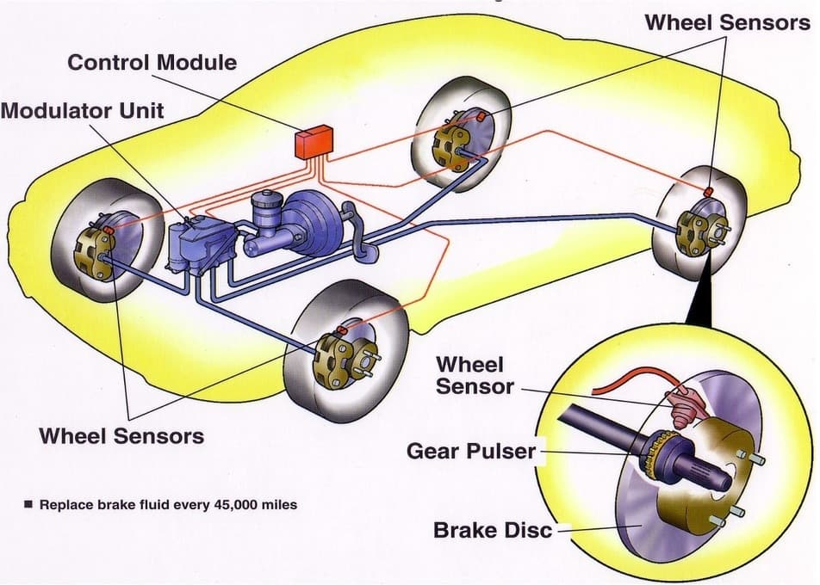





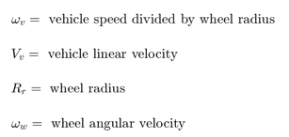

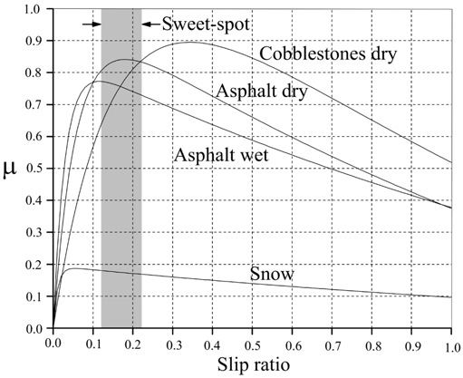

|  |  |
| --- | --- |
| 0, | 0, |
| 0.05, | 0.4, |
| 0.1, | 0.8, |
| 0.15, | 0.97, |
| 0.2, | 1, |
| 0.25, | 0.98, |
| 0.3, | 0.96, |
| 0.35, | 0.94, |
| 0.4, | 0.92, |
| 0.45, | 0.9, |
| 0.5, | 0.88, |
| 0.55, | 0.855, |
| 0.6, | 0.83, |
| 0.65, | 0.81, |
| 0.70, | 0.79, |
| 0.75, | 0.77, |
| 0.80, | 0.75, |
| 0.85, | 0.73, |
| 0.90, | 0.72, |
| 0.95, | 0.71, |
| 1 | 0.7 |

Torque = Tyre torque – Brake torque

Arbitrary Values:

Ctrl =1

g=32.18

Moment of inertia, I=5

Constant to account for area and perpendicular distance to find brake torque, Kf=1

Mass, m=50

Max. brake pressure, PBmax=1500

Wheel radius, Rr=1.25

TB=0.01

Initial vehicle velocity, V0=88